**DAILY ONLINE ACTIVITIES SUMMARY**

|  |  |  |  |  |  |  |  |  |
| --- | --- | --- | --- | --- | --- | --- | --- | --- |
| **Date:** | **01-06-2020** | | | | | **Name:** | **Nihal Rafiq** | |
| **Sem & Sec** | **4th A** | | | | | **USN:** | **4AL18CS052** | |
| **Online Test Summary** | | | | | | | | |
| **Subject** | | **Complex Analysis, Probability and Statistical Method** | | | | | | |
| **Max. Marks** | | **30** | | **Score** | | | **29** | |
| **Certification Course Summary** | | | | | | | | |
| **Course** | **Introduction to R** | | | | | | | |
| **Certificate Provider** | | | **Great Learning Academy** | | **Duration** | | | **2.5 hours** |
| **Coding Challenges** | | | | | | | | |
| **Problem Statement:**  **1. Give an array of positive integers. Write a C program to find the leaders in the array**  **2. Define a class Point with two fields x and y each of type double. Also, define a method distance (Point p1, Point p2) to calculate the distance between point p1 and p2 and return the value in double. Use Math.Sqrt ( ) to calculate the square root.**  **3. Give an array arr [] of size N and an integer K. The task is to find the count of subarrays such that each subarray has exactly K distinct elements.** | | | | | | | | |
| **Status: Executed** | | | | | | | | |
| **Uploaded the report in Github** | | | | | **Yes** | | | |
| **If yes Repository name** | | | | | **https://github.com/nihal-art/lockdown-coding** | | | |
| **Uploaded the report in slack** | | | | | **Yes** | | | |

Online Test Details:

The test was from module 5 of COMPLEX ANALYSIS, PROBABILITY AND STATISTICAL METHOD (18MAT41).The duration of the test was 40 minutes from 9.30am to 10.10am.There were two rounds in test .First round was of 10 mcq 1 mark each and second round 10 mcq 2 mark each. The score I received is 29/30.

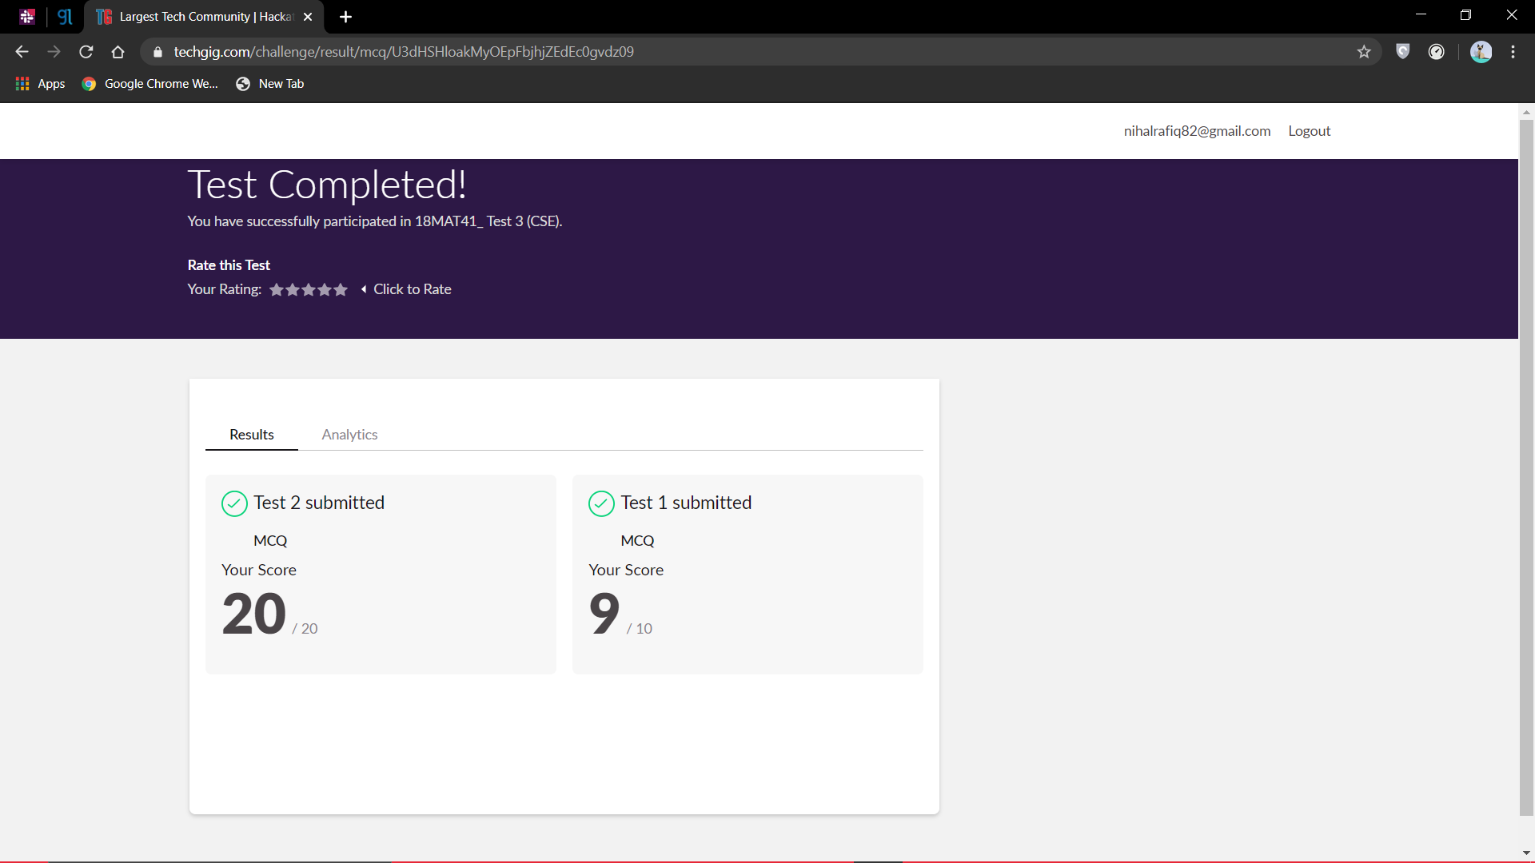

Certification Course Details:

I have opted to R certification course.

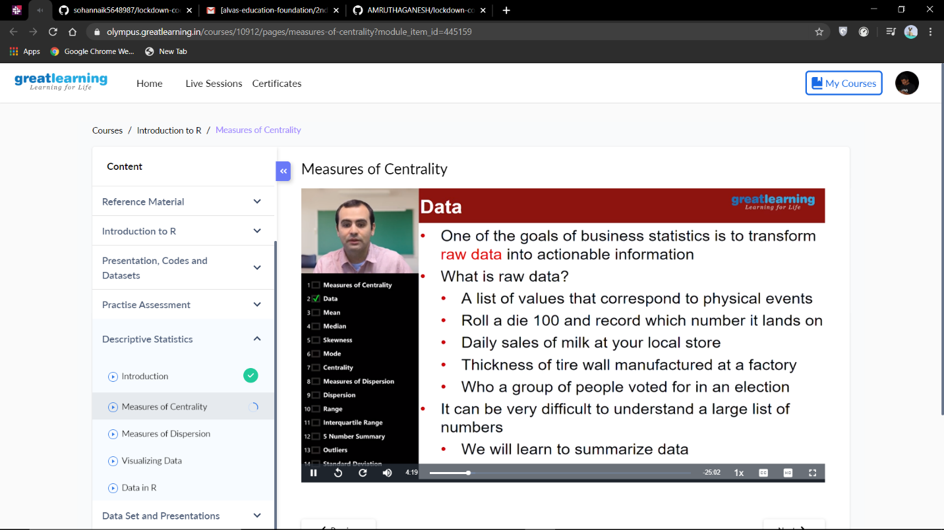

Coding Challenges Details:

**1. Give an array of positive integers. Write a C program to find the leaders in the array**

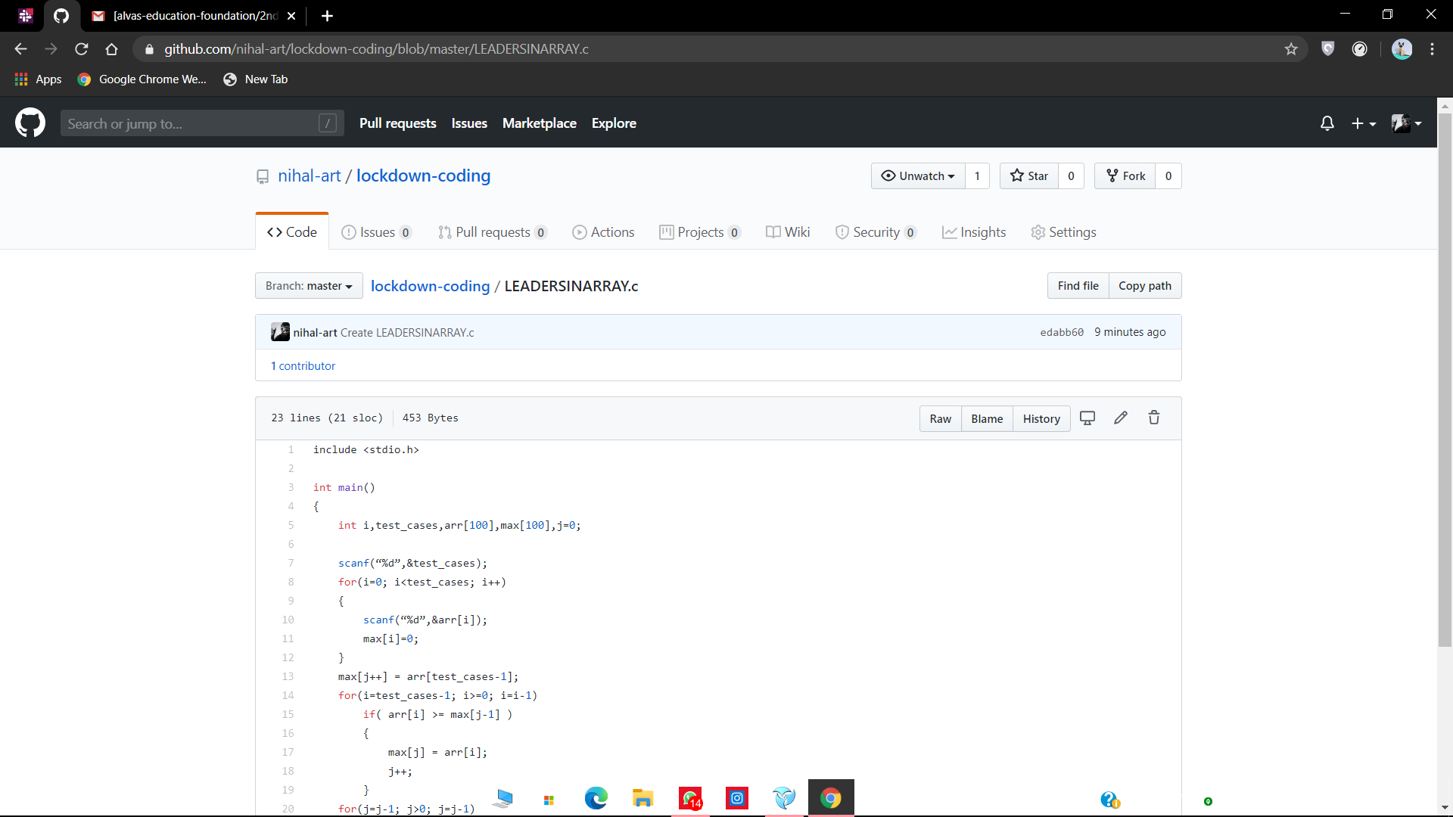

**2. Define a class Point with two fields x and y each of type double. Also, define a method distance (Point p1, Point p2) to calculate the distance between point p1 and p2 and return the value in double. Use Math.Sqrt ( ) to calculate the square root.**

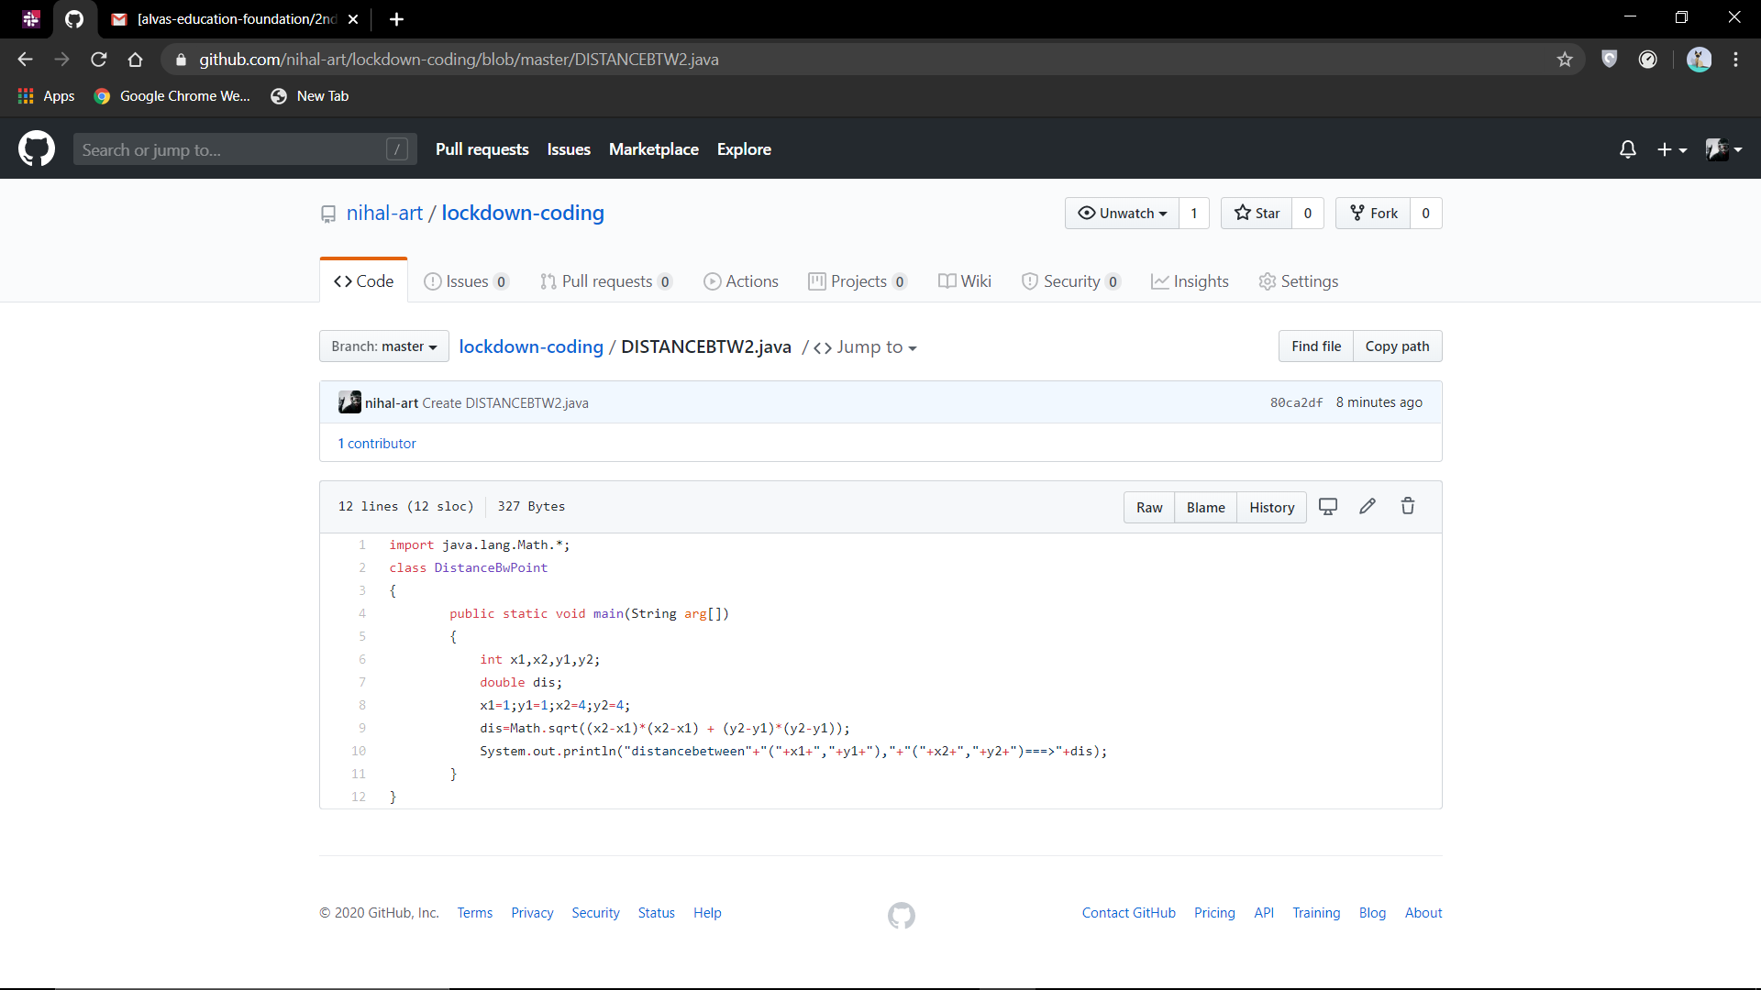

**3. Give an array arr [] of size N and an integer K. The task is to find the count of subarrays such that each subarray has exactly K distinct elements.**

